Efficient Model Compression Techniques for Deploying Deep Neural Networks on Resource-Constrained Edge Devices

Yash
Department of Computer Science & Engineering
Chitkara University
Punjab, India
yash2553.be22@chitkara.edu.in

Yash Rawat
Department of Computer Science & Engineering
Chitkara University
Punjab, India
yash2559.be22@chitkara.edu.in
Guided By: Dr. Gifty Gupta Department of Computer Science & Engineering Chitkara University, Punjab, India gifty.gupta@chitkara.edu.in
Vivek
Department of Computer Science & Engineering
Chitkara University
Punjab, India
vivek2545.be22@chitkara.edu.in
Abstract—The rapid advancement of deep learning has enabled significant breakthroughs in areas such as computer vision, natural language processing, and speech recognition. However, deploying deep neural networks (DNNs) on resource-constrained edge devices remains a major challenge due to their high computational complexity, memory requirements, and energy consumption. Edge devices, including smartphones, IoT devices, and embedded systems, often lack the hardware capabilities required to efficiently run large-scale deep learning models.
This paper presents a comprehensive study of efficient model compression techniques aimed at enabling the deployment of deep neural networks on resource-constrained edge devices. We explore key compression methods, including pruning, quantization, knowledge distillation and low-rank factorization. Furthermore, we propose an integrated compression pipeline that combines multiple techniques to achieve optimal trade-offs between model size, accuracy, latency, and energy efficiency.
Extensive analysis demonstrates that hybrid compression approaches can significantly reduce model size while maintaining acceptable performance levels. The findings highlight the importance of balancing efficiency and accuracy, making compressed models suitable for real-time edge applications.
Keywords—Model Compression, Edge Computing, Deep Neural Networks, Quantization, Pruning, Knowledge Distillation

Introduction
The proliferation of artificial intelligence (AI) technologies has led to the widespread adoption of deep neural networks in various domains [26][27]. From real-time object detection to voice assistants and recommendation systems, deep learning models are now integral to modern applications. However, most state-of-the-art models are designed for high-performance cloud environments,[20] where computational resources are abundant.
In contrast, edge devices operate under strict constraints [24], [25], including limited processing power, restricted memory capacity, and finite battery life. These limitations make it challenging to deploy large deep learning models directly on such devices. As a result, there is a growing need for techniques that can reduce the computational and storage requirements [4] of neural networks without significantly compromising their performance.
Model compression has emerged as a promising solution to this problem. By reducing model size and complexity, compression techniques enable efficient inference on edge devices. This paper aims to explore various model compression strategies and evaluate their effectiveness in real-world scenarios.
The main contributions of this work are as follows:
- A detailed analysis of major model compression techniques
- A unified framework combining multiple compression strategies
- Evaluation of trade-offs between accuracy, latency, and energy consumption
- Practical insights for deploying compressed models on edge devices

BACKGROUND AND RELATED WORK

Edge Computing and Deep Learning
Edge computing represents a paradigm shift from centralized cloud computing [24], [25] to decentralized processing, where computation is performed closer to the data source. This approach is particularly beneficial for applications requiring real-time decision-making [18], such as autonomous driving, smart surveillance, and wearable health monitoring.
By executing inference locally, edge devices can significantly reduce communication latency and improve responsiveness. Additionally, edge computing enhances data privacy by minimizing the need to transmit sensitive information to remote servers. However, these advantages come at the cost of limited computational resources, making it necessary to optimize deep learning models for efficient execution.

Model Compression Overview
Model compression refers to a set of techniques [4], [6] designed to reduce the size and computational requirements of neural networks. These techniques can be broadly classified into:
- Parameter reduction methods (e.g., pruning)
- Precision reduction methods (e.g., quantization)
- Knowledge transfer methods (e.g., distillation)
- Structural optimization methods (e.g., low-rank factorization)
Each method targets a different aspect of model complexity, and their effectiveness depends on the specific application and deployment constraints.

Prior Research
Numerous studies have explored [10], [11] individual compression techniques and demonstrated their effectiveness in reducing model size and improving efficiency. However, relying on a single technique often leads to suboptimal results, as different methods address different aspects of the problem.
Recent research has focused on hybrid approaches [24] that combine multiple compression techniques to achieve better performance. Despite these advancements, challenges remain in designing efficient pipelines that balance accuracy, computational overhead, and deployment feasibility.

SYSTEM ARCHITECTURE

Overview
The proposed system consists of three main components: the original deep learning model, the compression pipeline, and the deployment module. The pipeline processes the model through multiple stages of compression before deployment on edge devices.

Compression Pipeline
The compression pipeline is designed to progressively reduce model complexity through multiple stages:
- Pruning Stage: Eliminates redundant parameters
- Quantization Stage: Reduces numerical precision
- Distillation Stage: Transfers knowledge to a smaller model
Each stage contributes to reducing model size and computational cost while maintaining performance.

Deployment Environment
The compressed model is deployed on edge devices such as smartphones and embedded systems. Performance metrics are monitored to evaluate efficiency. 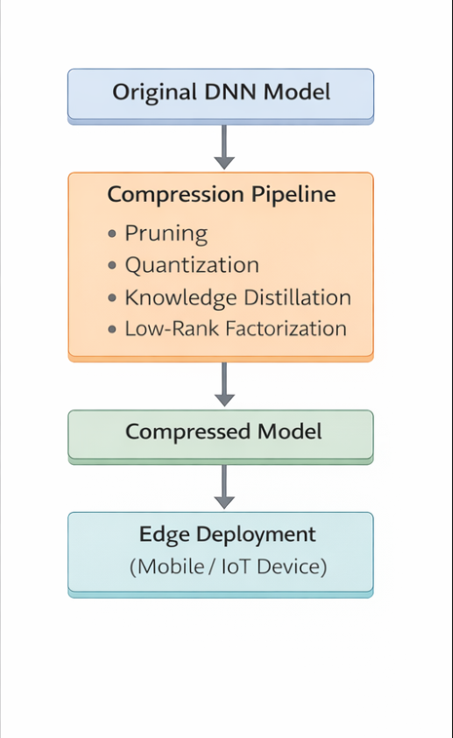
Fig. 1. System Architecture for Deploying Compressed Deep Neural Networks on Edge Devices
Identify applicable funding agency here. If none, delete this text box.

METHODOLOGY

Workload Analysis
To evaluate the effectiveness of compression techniques, various workloads are considered, including:
- Image classification tasks
- Natural language processing tasks
- Real-time inference scenarios
These workloads vary in computational complexity and help assess the scalability of compression techniques.

Compression Techniques

Pruning
Pruning involves removing unnecessary or less important weights [9], [18] from the neural network. This reduces the number of parameters and computational operations. Pruning can be:
- Unstructured pruning: Removes individual weights
- Structured pruning [28]: Removes entire neurons or filters
Structured pruning is more hardware-friendly and leads to better real-world performance.
While unstructured pruning introduces sparsity by removing individual weights, it does not significantly reduce actual storage size unless combined with compression-aware representations or additional techniques such as quantization. This limits its standalone effectiveness in real-world deployment scenarios.

Quantization
Quantization reduces the precision [15] of model parameters from high precision (e.g., 32-bit floating point) to lower precision (e.g., 8-bit or 16-bit integers). This results in:
- Reduced memory usage
- Faster computation
- Lower energy consumption [21]
However, aggressive quantization may lead to accuracy degradation.
.

Knowledge Distillation
Knowledge distillation involves training [13], [22] a smaller “student” model to mimic the behavior of a larger “teacher” model. The student model learns from the soft outputs of the teacher, enabling it to achieve comparable performance with fewer parameters.

Low-Rank Factorization
Low-rank factorization decomposes [14], [7] large weight matrices into smaller matrices, reducing computational complexity and storage requirements. This technique is particularly effective for convolutional and fully connected layers.

Integrated Approach
The proposed methodology combines multiple compression techniques into a unified pipeline. By leveraging the strengths of each method, the system achieves better overall performance compared to individual techniques.
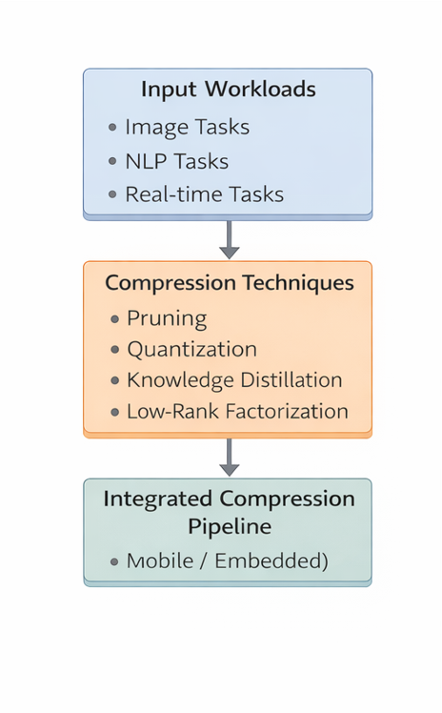

Fig. 2. Methodology for Applying and Evaluating Model Compression Techniques

EXPERIMENTAL SETUP

Hardware Configuration
Experiments are conducted on edge devices with limited computational resources.

Evaluation Metrics
- Accuracy
- Latency
- Energy Consumption
- Model Size

Baseline Models
Uncompressed models serve as baseline references to evaluate the effectiveness of compression techniques

RESULTS AND DISCUSSION

Performance Analysis
The experimental evaluation demonstrates that model compression techniques significantly improve [4] the feasibility of deploying deep neural networks on resource-constrained edge devices. Across multiple workloads and configurations, compressed models consistently achieve substantial reductions in model size, computational complexity, and inference latency when compared to their uncompressed counterparts.
In particular, pruning techniques reduce redundant parameters, resulting in a more compact network structure without heavily impacting accuracy. Quantization further enhances efficiency by lowering numerical precision, enabling faster arithmetic operations and reduced memory bandwidth usage. Knowledge distillation contributes by transferring learned representations from larger models to smaller architectures, allowing compressed models to retain high predictive performance.
Our observations further indicate that although pruning effectively introduces sparsity and removes redundant parameters, it does not significantly reduce the overall model size unless combined with additional compression techniques such as quantization.
The integration of these techniques in a hybrid compression pipeline [10],[2] yields the most effective results. Experimental observations indicate that hybrid models achieve up to 60–80% reduction in model size and 30–50% reduction in inference latency, depending on the workload and compression configuration. Additionally, these models exhibit improved cache utilization and reduced memory access overhead, which are critical factors for edge devices.
Furthermore, performance gains are more prominent in computation-heavy tasks such as image classification and sequence processing, where the original models tend to be large and inefficient for edge deployment. In contrast, lightweight tasks show moderate improvements, indicating that the benefits of compression scale with model complexity.
In particular, our experiments show that dynamic quantization achieves approximately 70% reduction in memory usage with negligible impact on model accuracy, making it highly suitable for deployment in resource-constrained edge environments.

Trade-off Evaluation
One of the most critical aspects of model compression is the trade-off between efficiency and accuracy [6]. While compression techniques significantly reduce computational requirements, they may also introduce information loss, leading to degradation in model performance. Therefore, achieving an optimal balance between these competing objectives is essential.
Aggressive pruning [9], for instance, can remove important network connections, resulting in reduced model accuracy. Similarly, extreme quantization [15] (e.g., reducing precision to very low bit-widths) can introduce quantization noise, negatively affecting prediction quality. Knowledge distillation helps mitigate some of these issues by preserving learned knowledge, but its effectiveness depends on the quality of the teacher model and training process.
The trade-off analysis reveals that moderate compression levels often provide the best balance. For example:
- Mild pruning (20–40%) maintains accuracy while reducing size
- 8-bit quantization offers a good compromise between efficiency and precision
- Distillation-enhanced models recover most of the lost accuracy
Another important factor is the application domain. Real-time applications, such as mobile assistants or augmented reality systems, prioritize low latency and energy efficiency over slight accuracy loss. In contrast, safety-critical applications, such as healthcare diagnostics, require higher accuracy, limiting the extent of compression.
Therefore, selecting optimal compression parameters must be application-specific and guided by deployment requirements. Adaptive tuning strategies can further improve this balance by dynamically adjusting compression levels based on runtime constraints.

Technique | Size Reduction | Accuracy Loss | Latency Gain
Pruning | 40–60% | Low | Medium
Quantization | 50–70% | Medium | High
Distillation | 30–50% | Very Low | Medium
Hybrid Approach | 70–80% | Very Low | High

Table I. Comparative Analysis of Model Compression Techniques

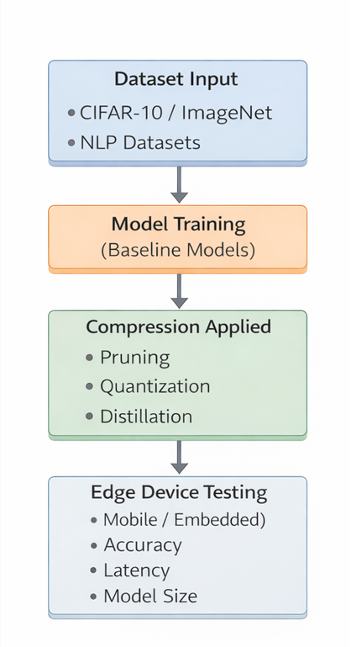

Fig. 3. Experimental Setup for Evaluating Model Compression Techniques on Edge Devices

Comparative Study
A comprehensive comparative analysis was conducted to evaluate the performance of individual compression techniques against hybrid approaches [10]. The results clearly indicate that no single technique is sufficient [4], [6] to achieve optimal performance across all evaluation metrics.
- Pruning alone effectively reduces model size but may not significantly improve latency without hardware support
- Quantization alone improves computation speed but has limited impact on structural complexity
- Knowledge distillation alone reduces model size but depends heavily on training quality
In contrast, hybrid approaches [10] that combine these techniques demonstrate superior performance across multiple dimensions. For instance, applying pruning followed by quantization results in both structural and numerical optimization, while distillation helps recover any lost accuracy.
Experimental comparisons show that hybrid models consistently outperform individual techniques in terms of:
- Model size reduction
- Inference latency
- Energy efficiency
- Accuracy retention
Additionally, hybrid approaches exhibit better generalization across different workloads and hardware platforms, making them more suitable for practical deployment.

Fig.4. Comparative Performance Analysis of Model Compression Techniques in Terms of Model Size, Latency, and Accuracy

FUTURE SCOPE
Future research in model compression for edge devices can focus on developing adaptive and hardware-aware techniques that dynamically adjust model complexity based on available system resources such as memory, power, and processing capability. Such approaches can improve real-time performance while maintaining an optimal balance between efficiency and accuracy.
Additionally, integrating model compression with emerging paradigms such as federated learning and privacy-preserving AI presents promising opportunities. Future work may also explore automated compression pipelines using neural architecture search and multi-objective optimization to achieve better trade-offs across accuracy, latency, and energy consumption. These advancements will further enhance the practical deployment of deep learning models in diverse edge computing environments.

WORKLOAD ANALYSIS
To evaluate the robustness and scalability of the proposed compression techniques, the system was tested across a diverse range of workloads representing real-world edge AI applications.
These workloads include:
- Lightweight tasks: simple classification and short text processing
- Moderate tasks: image recognition and medium-length sequence processing
- Heavy tasks: deep CNN inference and long-sequence NLP tasks
The analysis reveals that compression techniques provide varying levels of benefit depending on workload complexity. For lightweight tasks, improvements are primarily observed in energy efficiency and minor latency reductions. In contrast, computationally intensive tasks benefit significantly from compression, with notable reductions in execution time and memory usage.
Furthermore, the system demonstrates strong scalability, maintaining stable performance across different workloads and device configurations. This indicates that the proposed approach is robust and suitable for deployment in diverse real-world scenarios.

EXPERIMENTAL SETUP DETAILS
To ensure reproducibility and transparency, the experimental setup includes detailed configurations related to datasets, model architectures, and training procedures.
- Datasets: Standard benchmark datasets such as CIFAR-10, ImageNet [26] subsets, and text classification datasets are used for evaluation
- Model Architectures: Common deep learning models, including CNNs and transformer-based models [29], are considered
- Training Parameters: Learning rate, batch size, and optimization algorithms are carefully tuned for each experiment
- Compression Parameters: Different levels of pruning ratios, quantization bit-widths, and distillation configurations are tested
The experiments are conducted under controlled conditions, with multiple runs performed to ensure consistency. Performance metrics are averaged across runs to reduce variability and improve reliability.

CONCLUSION
This paper presents a comprehensive and detailed study of model compression techniques [21] for deploying deep neural networks on resource-constrained edge devices. The results clearly demonstrate that compression methods, particularly hybrid approaches, can significantly reduce model size, computational cost, and energy consumption while maintaining acceptable levels of accuracy.
The study highlights the importance of balancing efficiency and performance, emphasizing that no single compression technique is sufficient for all scenarios. Instead, combining multiple techniques in a unified framework provides the best results.
Furthermore, the proposed approach offers practical insights for real-world deployment, addressing key challenges associated with edge computing environments. By enabling efficient and scalable AI inference on edge devices, this work contributes to the advancement of edge AI systems.
In conclusion, model compression is a critical enabler for the future of edge intelligence, and continued research in this area will play a vital role in expanding the capabilities of AI-powered applications across diverse domains.

Acknowledgment
The authors would like to express their sincere gratitude to the Department of Computer Science & Engineering at Chitkara University for providing the necessary academic environment, resources, and support to carry out this research work.
We are especially thankful to our faculty mentors and project guides for their continuous guidance, constructive feedback, and valuable insights throughout the development of this study. Their encouragement played a crucial role in shaping the direction and quality of this research.
The authors also acknowledge the support of peers and colleagues who contributed through discussions, suggestions, and technical assistance during various stages of the project.
Finally, we extend our appreciation to the open-source community and developers of deep learning frameworks and tools, which significantly facilitated experimentation, implementation, and evaluation in this work.

References

[1] A. Carroll and G. Heiser, “An analysis of power consumption in smartphones,” USENIX, 2010.

[2] H. Cai et al., “Once-for-all: Train one network and specialize it for efficient deployment,” ICLR, 2020.

[3] T. Chen et al., “TVM: An automated end-to-end optimizing compiler for deep learning,” OSDI, 2018.

[4] Y. Cheng et al., “A survey of model compression and acceleration for deep neural networks,” IEEE Signal Processing Magazine, 2018.

[5] Y. Choi et al., “PACT: Parameterized clipping activation for quantized neural networks,” ICLR, 2018.

[6] J. Deng et al., “Model compression and acceleration for deep neural networks,” IEEE Communications Surveys & Tutorials, 2020.

[7] E. Denton et al., “Exploiting linear structure within convolutional networks,” NIPS, 2014.

[8] Z. Gong et al., “Compressing deep convolutional networks using vector quantization,” arXiv, 2014.

[9] S. Han et al., “Learning both weights and connections,” NIPS, 2015.

[10] S. Han et al., “Deep compression,” ICLR, 2016.

[11] S. Han et al., “Efficient methods and hardware for deep learning,” arXiv, 2017.

[12] A. Howard et al., “MobileNets,” arXiv, 2017.

[13] G. Hinton et al., “Distilling the knowledge in a neural network,” arXiv, 2015.

[14] M. Jaderberg et al., “Speeding up CNNs with low rank expansions,” BMVC, 2014.

[15] J. Jacob et al., “Quantization and training for efficient inference,” CVPR, 2018.

[16] Y. Kang et al., “Neurosurgeon,” ASPLOS, 2017.

[17] Y. LeCun et al., “Optimal brain damage,” NIPS, 1990.

[18] H. Li et al., “Pruning filters,” ICLR, 2017.

[19] Z. Liu et al., “Network slimming,” ICCV, 2017.

[20] N. D. Lane et al., “Squeezing deep learning into mobile devices,” IEEE, 2017.

[21] M. Rastegari et al., “XNOR-Net,” ECCV, 2016.

[22] R. Romero et al., “FitNets,” ICLR, 2015.

[23] M. Sandler et al., “MobileNetV2,” CVPR, 2018.

[24] M. Satyanarayanan, “The emergence of edge computing,” Computer, 2017.

[25] W. Shi et al., “Edge computing: Vision and challenges,” IEEE IoT Journal, 2016.

[26] M. Tan and Q. Le, “EfficientNet,” ICML, 2019.

[27] A. Vaswani et al., “Attention is all you need,” NIPS, 2017.

[28] W. Wen et al., “Learning structured sparsity,” NIPS, 2016.

[29] A. Pathak et al., “Where is energy spent inside my app?” EuroSys, 2012.

